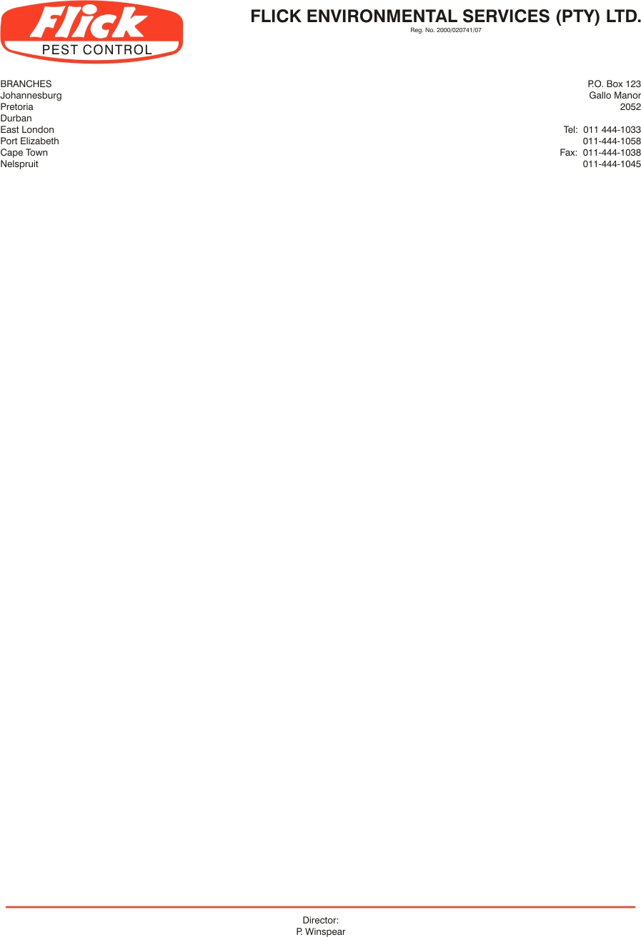
0
Invoice to: SLO-JO

Postal Address: P.O.Box 1985 Highland North 2037

Contact person: Irene Tel: (011) 608-0607

E-mail: irene@slo-jo.co.za

Service address: No 7 Saturn Crescent Limbro Business Park Limbro Park

VAT no: 4870194133

SERVICE AGREEMENT NO 191113

- FLICK PEST CONTROL agrees to carry out inspections and treatments at the addresses noted above to bring under control any infestation by Rats, Mice and Cockroaches in following areas. As per service schedule. Haccp

- FLICK PEST CONTROL agrees to carry out such further inspections and treatments as may be necessary to maintain control of these pests on these premises. Services will be done on a monthly cycle to maintain control of the above pests.(Minimum of 12 treatments and inspections per annum)

- In the event of re-infestation by specified pests anytime during the life of the agreement, FLICK PEST CONTROL will make additional inspections and treatments as to re-establish control of the pests at no extra charge to the client.

- The client agrees to pay for these services at the rate of R1575.00 (Exc. VAT) for the initial service. Thereafter R1575.00 (Exc.VAT) monthly. The first payment is due on the commencement of the agreement and the subsequent payments monthly thereafter. This price is subject to inflationary increases which take effect periodically.

- This agreement is binding for one year from this date. Notice in writing is required to terminate the agreement at the end of the first year, or thereafter 3 months’ notice.

Signed this __________ day of November 2013 Commencement date 20th November 2013

Client signature: ________________________ For Flick: _______________________

Client name: ________________________ Ronel Schoeman
082-339-4485

